Experiment 8

Nmap Service Version and OS Detection

Aim
To perform service version detection and operating system identification using Nmap.

Theory
Nmap (Network Mapper) is an open-source network scanning tool used for network discovery and security auditing.

Commands

i) Detect Service Versions
nmap -sV 192.168.1.10
Description:
Determines the versions of services running on target ports.

ii) Aggressive Scan
nmap -A 192.168.1.10
Description:
Performs OS detection, version detection, script scanning, and traceroute.

iii) Operating System Detection
sudo nmap -O 192.168.1.10
Description:
Identifies the operating system running on the target host.

Sample Output
PORT STATE SERVICE VERSION
22/tcp open ssh OpenSSH 8.2
80/tcp open http Apache 2.4
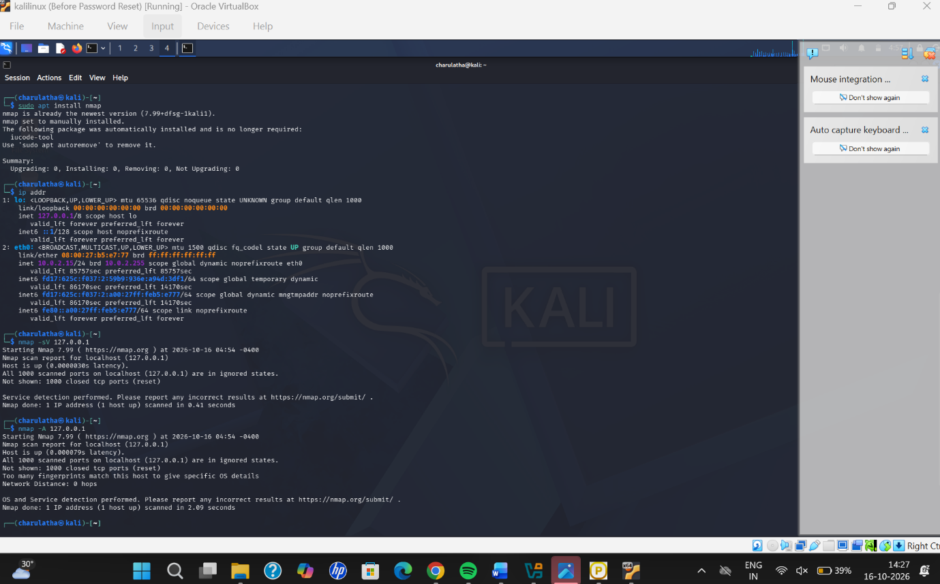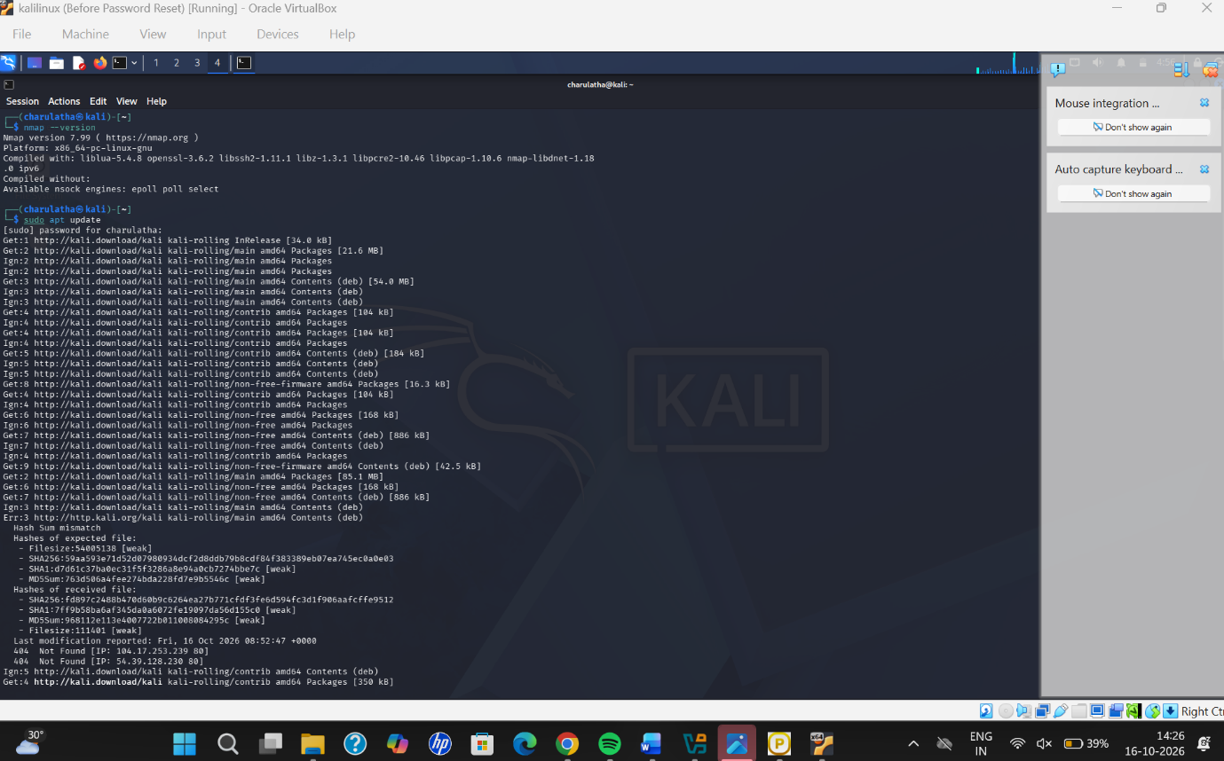

Result
Successfully performed service version detection and OS identification using Nmap.

